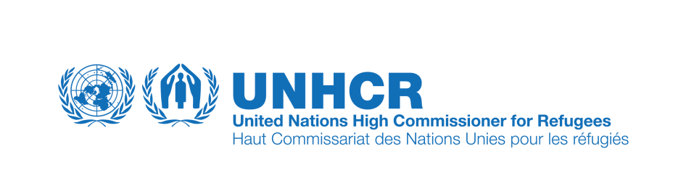
New UNHCR Web Portal Launch
Guidance for Emergency Managers and Coordinators: What you need to know

A. How to request and launch a web portal
- To initiate deployment of a new regional web portal, the country information manager should first seek approval from the Country Representative. The Representative submits a Portal Deployment Request Form (template attached to the Emergency Handbook Entry and available at http://data.unhcr.org/imtoolkit) to the Regional Representative and/or Regional Refugee Coordinator (as applicable), who consults relevant Country Representatives and information managers in the region, and then forwards the proposal to the Bureau and FICSS chief of section. Send the Portal Deployment Request Form for the FICSS chief of section to: webportal@unhcr.org).

- For country-level portals, consultation with the Regional Representative is not required. The Country Representative may submit a Portal Deployment Request Form (link for download noted above) directly to the Bureau and FICSS. In Level 2 or 3 emergencies, the HQ Emergency Task Force may initiate a portal request.

- Additional detailed information surrounding the launch and maintenance of a web portal is available on the Toolkit, at: http://data.unhcr.org/imtoolkit/chapters/view/web-portal/lang:eng and can also be found in the Emergency Handbook entry for this section.

B. Key facts on the web portal
- The web portal is located at http://data.unhcr.org. The portal should be promoted to in-country partners, who should use the portal for information needs as well as provide additional information to post there (for example ‘Who’s Doing What Where’ information, in addition to reports and analysis covering the emergency etc.).

- There is a standard press release available for download on the Toolkit, under ‘Examples’ at: http://data.unhcr.org/imtoolkit/chapters/view/web-portal/lang:eng that can be issued on the day the portal officially launches.

- The web portal’s purpose is to disseminate key operational information needed by decision-makers in real-time. The portal is publicly accessible and the information will be used by UNHCR staff, humanitarian actors, governments, donors and others.

- Your operation in-country is responsible for updating the information on the web portal for your situation.

- In-country management is responsible for clearing information and authorizing information to be posted on the portal. Recommended steps for portal clearance and maintenance are available for download on the Toolkit at: http://data.unhcr.org/imtoolkit/chapters/view/web-portal/lang:eng under ‘Tools’ titled, ‘UNHCR Emergency Web Portal Content Management Process Template’.

- Time is of the essence. Information needs to be rapidly posted to the portal so that it may inform emergency response for UNHCR and our partners.

What you need to do:

- Establish a focal point for information management who will gather data from others and post it on the portal.

- Define SOPs for clearing information to be posted on the web portal. An appropriate level of in-country management should approve data before it is posted.

- Decide which geographic locations in-country will be covered by the portal.

- Decide which information elements can be posted on the portal when it first launches.

- Find the following information:

  - Population statistics (Potential sources: registration data, rapid population estimations, other humanitarian actors, government). Note: the web portal CANNOT launch without population statistical information.

  - “Who Does What Where” (Potential sources: coordination meetings, Programme Officers, Field Officers).

  - Needs assessments, fund-raising appeals, maps or any other operational documents that are useful to the broader humanitarian community.

