**Measurement of height and weight for children**

**Measurement of height for children 85/87 cm and above**

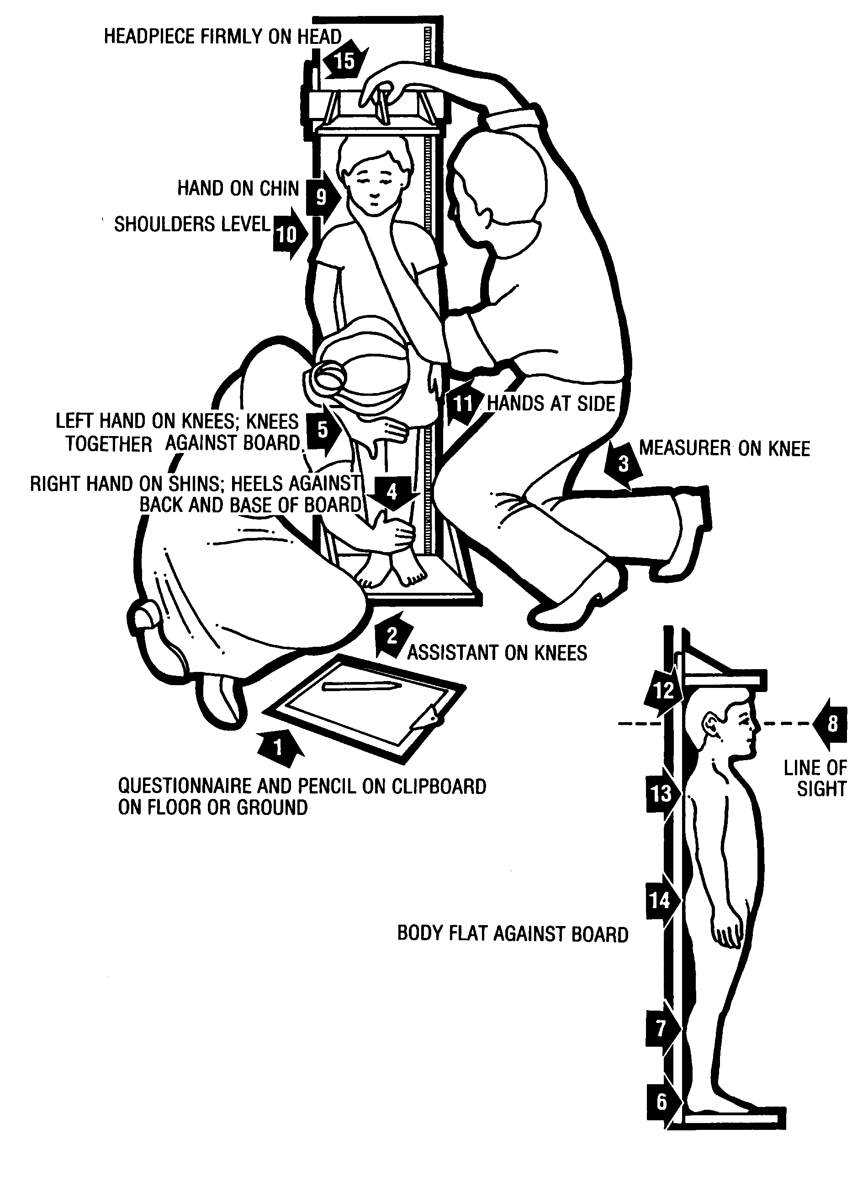

**Measurement of length for children <85/87 cm**

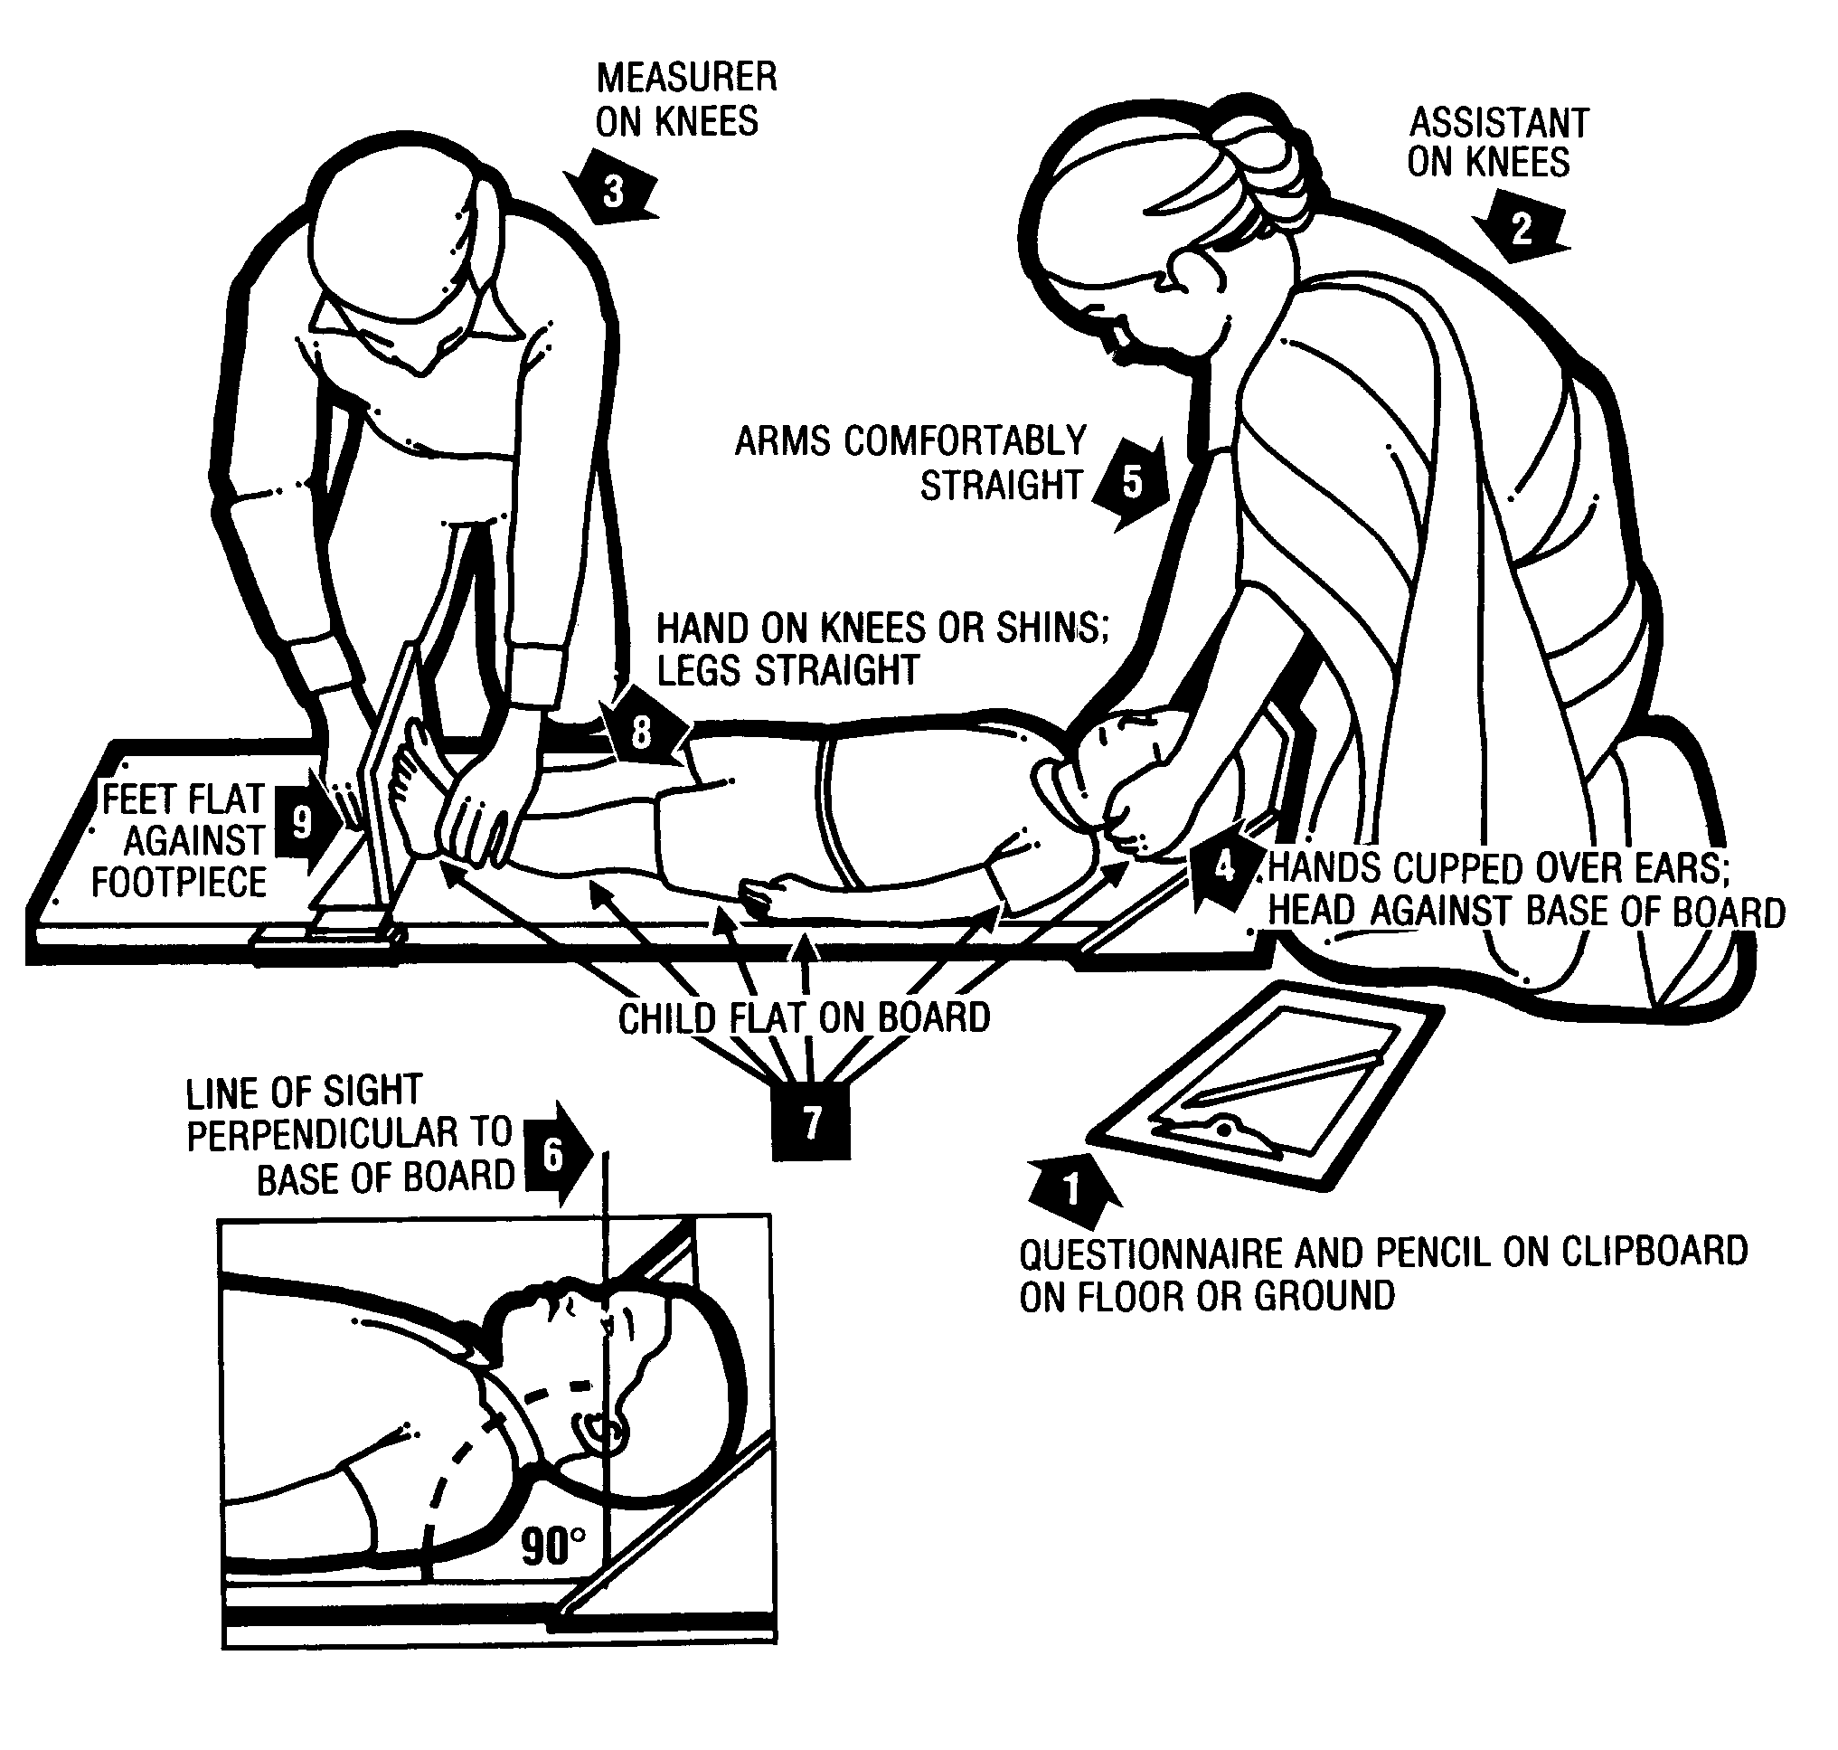

**Measurement of weight with the electronic scale (mother-child function)**

