Contingency Plan (CP)

[COUNTRY Operation]

Risk Covered:
[...NAME...] Situation

XXXXX | CP figure of persons to be assisted (projected additional displacement for 3 months from the CP activation)
$ XXX million | estimated resources required for the first 3 months (USD) of the response
XX | # of partners with whom the CP was developed
XX | # of other partners contributing to the response (Refugee Coordination Model (RCM))
$ XXXX | estimated preparedness resource requirements (USD)

CP valid from/to | [Date]
Updated on | [Date (Draft or Final)]
Is the CP part of a regional CP? | Yes/No
Level of preparedness | [Partially sufficient, sufficient, insufficient]
CP focal point | [Name]
Multi-Functional Team (MFT) involved in drafting of CP | [Titles]
CP developed with | [List all partners involved in developing the CP]
Other contributing partners (RCM) | [List other partners contributing to the response]

1. OPERATIONAL Context (Optional)

Response Capacity and Operational Context (< 300 words)

Briefly describe your operational context, including the existing response capacities (UNHCR and other UN agencies, government, other partners).

Complete this section if there have been any major changes in the operational context since the Operations Multi-Year Strategy was developed in the Situational Analysis Section in COMPASS. If there are no major changes, extract the Multi-Year Strategy and attach it to this CP as an annex.

2. Contingency Planning Scenario
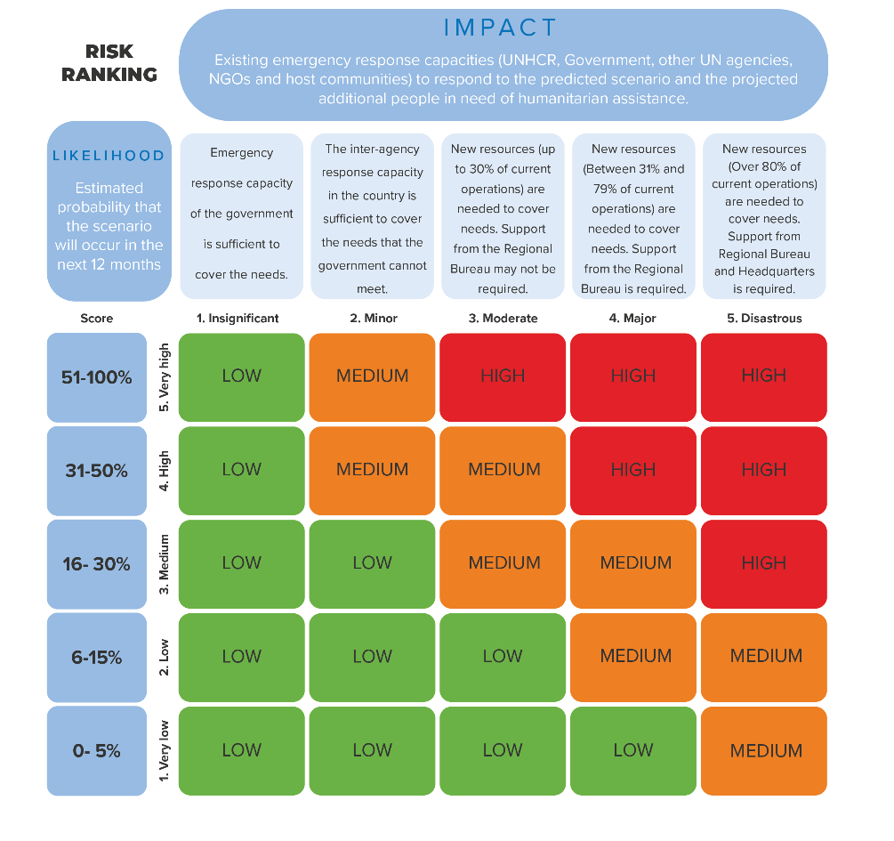
Planning Scenario (< 400 words)

Briefly describe the planning scenario with the highest risk level (e.g. border crossing points, pace and scale of displacement, profile of displaced, cause of influx/ displacement, foreseen population dynamics, axes of displacement…) and the expected humanitarian impact on the persons of concern, using an AGD approach. Any documentation related to the overall risk analysis and scenario development can be attached as an annex.
In situations of internal displacement, the planning scenario will be developed at Inter-Agency level. UNHCR should thereafter develop the agency-specific CP using the same scenario.

(To establish the planning scenario with the highest risk level, rank the scenarios on a scale from 1 to 5 by multiplying likelihood and impact. Likelihood is the estimated possibility that a scenario may occur within the next year. The potential impact is the negative consequences of a scenario on the operation’s current capacity to respond.)

High risk scenario:

Expected humanitarian consequences & impact on the population of concern:

3. Population planning figures and activation triggers

1) Population Planning Figures

Population Group | Current population figure (number of individuals) | CP figure (projected new displacement for first 3 months of emergency response) * | CP figure of persons to be assisted (for first 3 months of emergency response) * | Notes (e.g. population profile/ breakdown, information on specific needs)
Refugees and asylum-seekers
IDPs
Host community/other affected population to be assisted under this plan

* This will include the displacement figures that trigger the contingency plan

2) Activation triggers

Specify one or more indicators (for instance, average # of daily new displacements in one week, # of new displacements in 7 days, # of new displacements in 30 days, proximity of violence to refugee/IDP settlements or capital, political negotiations fail/stall resulting in further escalation of the conflict) to be regularly monitored and measured. State whether these need to be individually or cumulatively met for a decision by the Representative to activate the CP.

No | Trigger indicators | Trigger value & level
1
2
3
4

The operation should determine monitoring intervals and focal points as well as activation process and actions.

4. Coordination arrangements

Summarize the existing and/or required coordination arrangements (< 600 words):

- Coordination with Government
Include an overview of the capacity and expected role of the Government at national and local level and the coordination with respective authorities (RCM or cluster system depending on the context).
- Inter-agency coordination
Briefly describe the capacity and preparedness of the humanitarian system. In a refugee context, describe the overall RCM structure. In an IDP context, describe if already existing any Inter-Agency continency planning led by OCHA (ERP model). If Clusters are not yet activated, highlight any foreseen plan and the position of UNHCR as cluster lead.
- UNHCR-internal coordination
Outline UNHCR’s internal coordination arrangements (Office structures, creation of MFT and reporting lines, other internal coordination arrangements).

5. Response Strategy, Partners and budget

1) Overall Response Strategy (< 1200 words)

Develop a context-specific response strategy narrative, outlining the best achievable approach to ensure the protection of the PoCs, and grounded in the key principles of the Policy on Emergency Preparedness and Response. Basic strategy points to cover in this section may include, but are not limited to:
- Access to territory and asylum (including border monitoring), and civilian character of asylum, specifically for refugee situations, freedom of movement
- Implementation of emergency Registration or enrolment (including biometrics) and Population Data Management or other population profiling
- Information Management support: e.g. type of information and analysis required to inform the emergency response, foreseen activities which require IM support and respective capacity needs, including for sectors/clusters
- Needs assessments, protection monitoring and community-based protection approaches
- AAP (including CwC)
- PSEA
- Strategy for prevention mitigation and response to GBV, child protection services, identification of and support to persons with specific needs
- In IDP context for protection: including protection monitoring, protection services, contribution to child protection and GBV activities and coordination role
- In IDP context: UNHCR-foreseen areas of intervention (shelter, NFI and CCCM)
- Shelter and settlement arrangements (urban/rural locations scattered, camp settings, transit centres, collective accommodations)
- Service provision: what services need to be provided at the various stages (entry points, way stations, transit locations, settlement, camp) and to whom (refugees, host community, IDPs)
- Modalities of implementation: implement directly and/or through partners
- Assess CBI’s viability as a form of assistance delivery, note inter-agency approaches and initiatives, describe UNHCR’s CBI strategy, list measures to mitigate protection risks in cash-based interventions
- State responsibility and humanitarian complementarity: considering the national capacities and the context, which are the priority assistance sectors/ clusters to cover gaps? Highlight key cross-cutting protection concerns for all sectors/ clusters
- If applicable: mixed population flows – how will third country nationals and returnees be assisted?
- Outline response constraints and strategies to address and mitigate them (including insecurity, other types of constraints on humanitarian access, transport and logistical challenges, administrative or bureaucratic impediments)
- Environmental sustainability and climate considerations: how is environmental sustainability mainstreamed across the response to minimize the environmental footprint? Are climate change considerations included as part of the response?
- Procurement and Supply: e.g. procurement strategy, logistics management, warehouse locations, accessibility and issues impacting relief support, distribution modalities
- Staff Safety and Security: outline the safety and security context for humanitarian workers in the operational area, main recommendations for mitigating measures, and ‘duty of care’
- IT Services and material resources: e.g. IT context, resources required to ensure efficient IT delivery and collaboration
- Administration and Human Resources Strategy/ Request for Deployments: e.g. current structure of UNHCR operation, including presence in the potentially affected area(s), and plans to expand UNHCR offices/presence for the emergency response, any immediate request for additional staff/ deployment and the most needed profiles of staff
- Communication and PI: UNHCR communication and PI strategy in relation to operational response and as sector/cluster lead
- Resource Mobilization Strategy (depending on RCM or Inter-Agency approach)
- Outline how the strategy contributes to durable solutions

2) Partners and Budget

- Summarize key sector/cluster-specific response activities in the table (details to be annexed).
- Any support to the host community should be integrated in the sector/cluster strategies, as appropriate.
- Indicate the partners that will be co-coordinating the response in line with coordination structure, and all other partners that will be involved in the response.
- Indicate the estimated response budget to implement the response in the first 3 months according to the scenario.
- The budget may be used for an emergency appeal or an RRP in consultation with the operation, the Regional Bureau and HQ. Therefore, this is UNHCR’s needs based (OP) budget (and in situations where UNHCR coordinates and leads an inter-agency response to a refugee situation should include appealing partner budgets). This CP, including the budget may be referred or attached to an OL increase request (including for an Emergency-reserved Budget) notification or memo. This budget (and CP) may be revised as the situation evolves and has no relation in COMPASS with your current budget. (Reminder: All requests for additional OP increase must be approved by the Board before sharing with HRP, RRP or CT)
- Please include budget areas such as inter-agency coordination, CBI, IM and data capacity, climate, staffing, admin, HR, security, travel, DSA, external engagement (PI/ ER/ donor relations, reporting, PSP) under the respective sectors/ clusters and AORs and to streamline AAP and PSEA activities throughout the budget.

UNHCR activities and budget (including UNHCR-funded partner activities)
Sector/ cluster and AOR | Outcome area | Response activities | Estimated response requirements (USD) for |  | Comment (direct implementation or partner)
 |  |  | refugee response | IDP response
Protection

General Protection

GBV

Child Protection
CCCM
Shelter & NFI
Food Security |  |  |  |  | For refugee or mixed contexts)
Health & Nutrition |  |  |  |  | For refugee or mixed contexts)
WASH |  |  |  |  | For refugee or mixed contexts)
Education |  |  |  |  | For refugee or mixed contexts)
Livelihoods/ Resilience
Emergency telecommunications/ IT
Logistics
Etc.
Total |  |  | sum of the above | sum of the above
Total |  |  | sum of the above

To be completed ONLY for refugee scenarios: Other partners' activities and budget should be listed below (non-UNHCR funded but participating in the UNHCR/government-led response)
- Please include budget areas such as CBI, IM and data capacity, climate, staffing, admin, HR, security, travel, DSA, external engagement (PI/ ER/ donor relations, reporting, PSP) under the respective sectors and to streamline AAP and PSEA activities throughout the budget.

Sector | Partners | Response activities | Estimated response requirements (USD) | Comment (Indicate available resources here)
Protection  General Protection  GBV  Child Protection | List the partners participating in the CP or contributing to the response, separated by a comma
Shelter & NFI
Health & Nutrition
Food Security
Education
WASH
Livelihoods & Resilience (and Socio- economic inclusion)
Logistics, Telecoms & Operations Support
Other
Total |  |  | sum of the above

6. PREPAREDNESS ACTIONS

Determine the preparedness actions to operationalize the response in the CP, including required resources. This represents UNHCR’s needs based (OP) budget to prepare for the emergency. The preparedness actions budget and the response budget (section 5.2 above) may be used for an emergency appeal in consultation with the operation, the Regional Bureau and HQ. The preparedness actions budget may be referred to / attached as part of the L1 emergency declaration request, and also to an OL increase request (including for an Emergency-reserved Budget) notification or memo. This may be revised as the situation evolves and has no relation in COMPASS with your current budget.

Preparedness Action | Focal point | Deadline | Estimated requirements (USD) |  | Comment
 |  |  | refugee preparedness | IDP preparedness
 |  | Total | sum of the above | sum of the above
 |  | Total (report this in first page) | sum of the above

See the list of preparedness actions on the Emergency Preparedness and Response Portal for guidance.

7. Annexes

Items in the annex may include:

- Coordination structure (according to RCM or cluster role)
- Detailed sector/cluster response strategies (as appropriate in IDP context Protection/ CCCM/Shelter-NFI)
- Sector/cluster gap analysis chart
- More details on UNHCR response strategies (for Protection, Shelter/NFI, CCCM, as appropriate)
- Protection Assessments (including Safety Audits, Child Protection Assessments, Information and Communication Needs Assessment)
- Results of camp/ settlement site assessments and camp/ settlement layout (as appropriate)
- Relevant maps (potentially affected areas, UNHCR presence and offices current and planned)
- List of UNHCR frame agreements
- Customs clearance procedures and timelines
- NFI stock - gap analysis against contingency scenario; international procurement needs from stockpiles and/or directly from suppliers
- Emergency IT EPRS Assessment Template and Emergency IT EPRS Preparedness Template
- Documentation of risk analysis conducted
- Inter-agency CP (if available) or at least UNHCR-led sector/cluster Operational Delivery plans included in the Inter-agency CP (ERP approach for IDP situations)
- Regional CP (if available)
- Operations Multi-Year Strategy extracted from COMPASS
- Any other relevant documents

OA1: Access/Doc, OA2 Status, OA3: Policy/Law, OA4: GBV, OA5: Children, OA6: Justice, OA7: Community, OA8: Well-being, OA9: Housing, OA10: Health, OA11: Education, OA12: WASH, OA13: Livelihood, OA14: Return, OA15: Resettle, OA16: Integrate, OA17: System, EA18: Support, EA19: People, EA20: External, EA21: Lead/Gov
Inc. HIV
Inc. HIV

